Security (9.3) Subsystem Architectural Description

Status: | Issued
Version: | 1.0
Team/Department : | Crypto Services/Core Development

Contents
1 Introduction 4
1.1 Purpose and Scope 4
1.2 Document Conventions 4
1.2.1 Type and formatting 4
1.2.2 Diagrams 4
2 Subsystem Overview and Background 5
2.1 The Security subsystem 5
2.1.1 Client OS Components 5
2.2 The Subsystem components 5
Subsystem Architecture 8
2.3 Cryptography 8
2.3.1 Component relationships 8
2.3.2 Subcomponents 8
2.3.3 Strong and weak versions of the crypto library 9
2.3.4 Internal relationships 11
2.4 Crypto token framework 11
2.4.1 Component relationships 11
2.4.2 Subcomponents 12
2.5 File Tokens 12
2.5.1 Subcomponents 13
2.5.2 Internal relationships 14
2.6 Certificate management 14
2.6.1 Component relationships 15
2.6.2 Subcomponents 15
2.6.3 Internal relationships 17
2.6.4 Certstore internal relationships 17
2.6.5 API Purpose — Further Elaboration 18
2.7 Software Install APIs 20
2.7.1 Components 20
2.7.2 Software Install Server APIs 22
2.7.3 Key External Relationships and Dependencies 23
2.7.4 API Purpose—Further Elaboration 23
2.8 Content Access Framework 30
2.8.1 APIs 30
2.8.2 Key Internal and External Relationships and Dependencies 31
2.8.3 API Purpose—Further Elaboration 31
2.9 TLS Provider 32
2.9.1 Component relationships 32
2.9.2 Subcomponents 32
2.10 Reference Certificate Store 33
2.11 Architectural Description and Elaboration 33
2.11.1 Client-server architecture 33
2.11.2 TCB vs. non-TCB code 33
3 System Architectural Requirements 33
4 Security 33
4.1 Data caging 33
4.2 Backup and restore 34
4.3 Capabilities 34
5 Further Information 34
5.1 References 34
5.2 Open Issues 34
5.3 Glossary 34

Introduction
The architecture of a proposed system does not appear in a flash. It takes exploration of the use cases, a proof-of-concept prototype, an architectural baseline, and other efforts during the Inception and Elaboration phases.
Ivar Jacobson. The Objector Software Development Process. Draft edition.

Purpose and Scope
This document details the architecture of the Security Subsystem in Symbian OS v9.2. It describes the exposed APIs as well the internal components used to implement them. It is intended for use by anyone implementing changes to the Security Subsystem mandated by introduction of Platform Security, as well as for anyone wishing to know more about the Security Subsystem architecture.
This document provides a high-level overview of the subsystem architecture. The APIs discussed are not illustrated by class diagrams. For detailed API description please refer to the Doxygen-generated documentation.

Document Conventions

Type and formatting
The following type and formatting conventions are used in this document:
Fixed This fixed-pitch typeface is used for file names, module names, code snippets, etc.
New This highlight is used to designate information new to the current version of the system that wasn’t there before

Diagrams
Dashed arrows are used to represent dependency, particularly static dependency (i.e. linking). Solid arrows are used to represent communication paths and dynamic dependency, i.e. client/server IPC and communication with ECom plugins.
Diagrams showing relationships within a component have been simplified – dependencies from a child to ancestors of its parents are not shown. In other words, if B depends on C and A depends on B and C, the dependency from A to C is not shown.

Subsystem Overview and Background

The Security subsystem
The Security Subsystem is intended to support:
- Secure communications protocols that provide data confidentiality, authentication and integrity.
- Authentication of installable software.
- Preservation of device integrity.
To that end it provides a set of basic security technologies such as cryptographic algorithms, smart card software and certificate/key management systems, as well as software installation and maintenance services.

Client OS Components
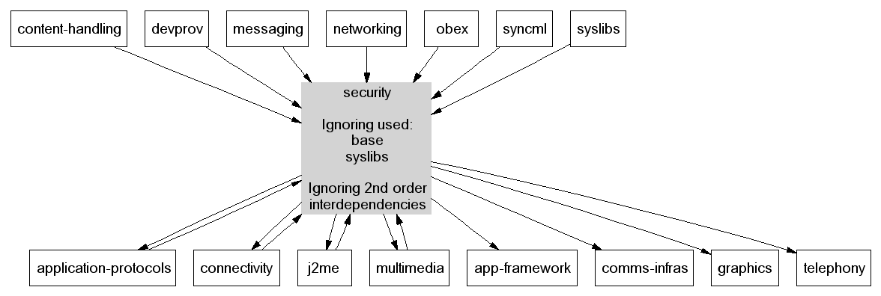

The Subsystem components
The Security subsystem is made up of the following components:
Name | Component | Description
Cryptography | security/crypto | Implements basic algorithms including symmetric and asymmetric ciphers, hashes, and a cryptographically strong random number generator.
Crypto token framework | security/cryptotokens | A framework that enables applications to use cryptographic functionality implemented on secure hardware tokens and software emulations of those tokens.  Standard interfaces are defined for certificate and key management.
Certificate management | security/certman | Certificate management includes:  - certificate storage and retrieval  - setting certificate applicability and trust  - certificate chain building and validation  - revocation checking (OCSP)  Also includes key management API:  - generation, import and export of RSA, DSA and DH key pairs  - listing available keys  - performing private key operations
File tokens | security/filetokens | Provides:  - software implementation of a keystore token  - software implementation of certstore token  - storage of certificate applications
Content Access Framework | security/caf2 | Provides a framework for implementation of DRM by licensees. Now maintained by Base Services.
Software install | security/swi  security/JavaMIDletInstaller | Handles software installation, including SISX and Java MIDlet package installation, and all related activities.
Tools | security/swi/makesis  security/swi/signsis  security/makekeys | PC based tools for creating SIS files.
Reference certificate store | security/rootcerts | A reference certificate store containing the certificates for the Symbian Signed program.
TLS support | security/tlsprovider | An interface to provide cryptographic support for the SSL/TLS protocol.

The following figure illustrates the dependency relationships between these components.
Figure 1: Dependencies between security components
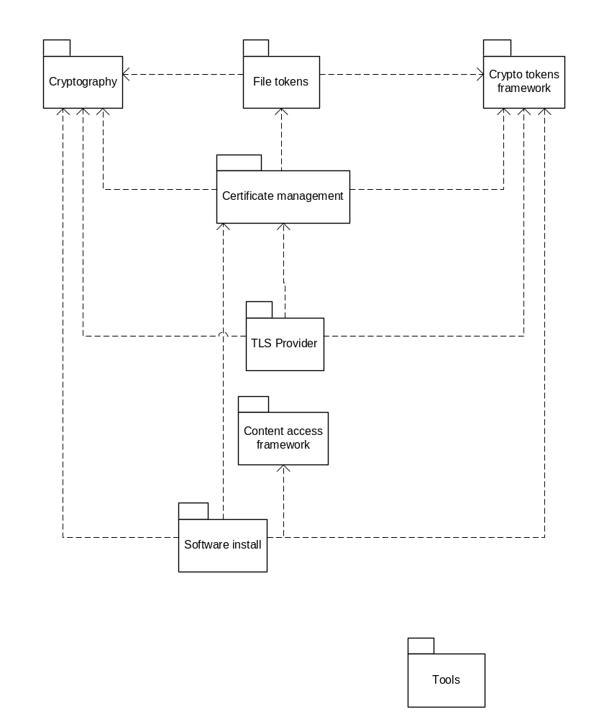

Subsystem Architecture
This section describes the composition of each component. Each sub-component corresponds to a library or executable built as part of the subsystem.

Cryptography

Component relationships
The following diagram shows component-level dependency relationships involving cryptography.
Figure 2: Cryptography component dependencies
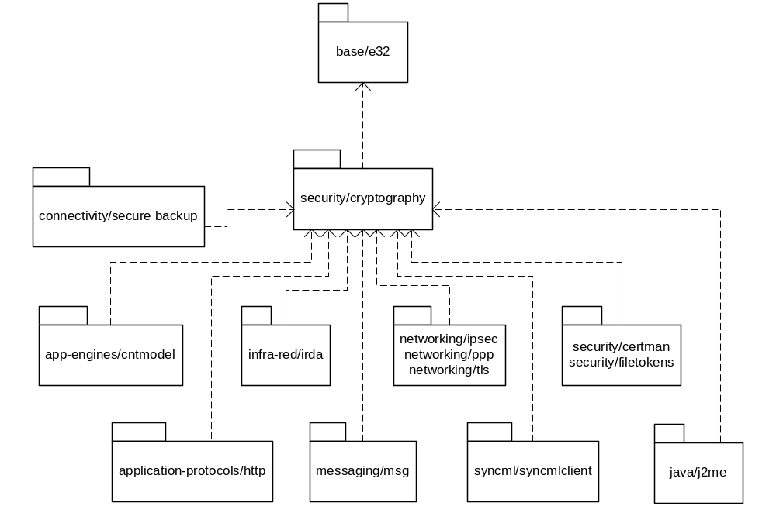

Subcomponents
Name and target | Purpose | Clients
Random number library  random.dll | API for generation of cryptographically strong random numbers | app-engines/cntmodel  networking/ipsec  networking/ppp  networking/tls  syncml/syncmlclient  security/certman
Random server  randsvr.exe | Implementation of random number generator | Internal use only
Hash library  hash.dll | API for generating cryptographic hashes.  Supports MD2, MD5, SHA1 and HMAC | application-protocols/http  infra-red/irda  messaging/msg  networking/ipsec  networking/ppp  networking/tls  syncml/syncmlclient  security/certman  security/filetokens  Software install
Crypto library  Two versions are built:  weak_cryptography.dll  strong_cryptography.dll  Clients link against: cryptography.dll | API providing the following:  - Symmetric ciphers (DES, 3DES, RC2, ARC4, AES)  - Asymmetric ciphers (RSA, DSA, DH)  - Padding schemes (PKCS#1, PKCS#7, SSLv3)  - Big integers | networking/ipsec  networking/ppp  networking/tls  security/certman security/filetokens  Software install
Crypto switch (emulator only)  cryptography.dll | Transparently forwards calls to the crypto library, selecting at runtime which version to use (strong if present, weak if not) | N/A
PBE  pbe.dll | API for password-based encryption:  - key generation from password (PKCS#5 key derivation function)  - secure encryption/decryption of single or multiple independent elements based on key | syslibs/store  security/certman  security/filetokens

Strong and weak versions of the crypto library
Two versions of the crypto library can be built – weak_cryptography.dll and strong_cryptograpy.dll. The weak version is limited to symmetric crypto operations with a maximum key size of 56 bits and asymmetric crypto operations with a maximum key size of 512 bits.
Clients always link against cryptography.dll. On hardware, the version used is determined at ROM build time by including the appropriate version of the crypto library as cryptography.dll. On the emulator, the crypto switch sub-component supplies cryptography.dll, and this transparently forwards calls to the appropriate version of the crypto library.
The diagrams below show the two situations that can occur on the emulator:
Figure 3: Crypto switch operation when only weak crypto library is present
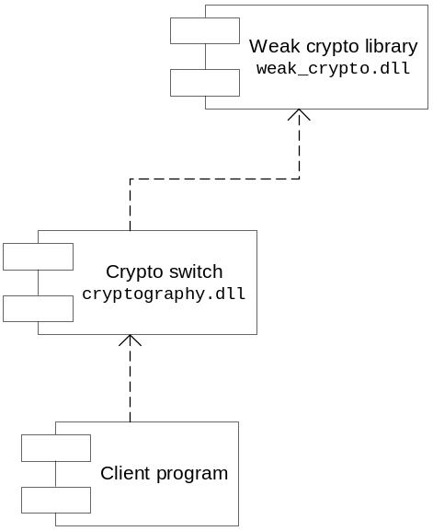

Figure 4: Crypto switch operation when weak and strong versions present
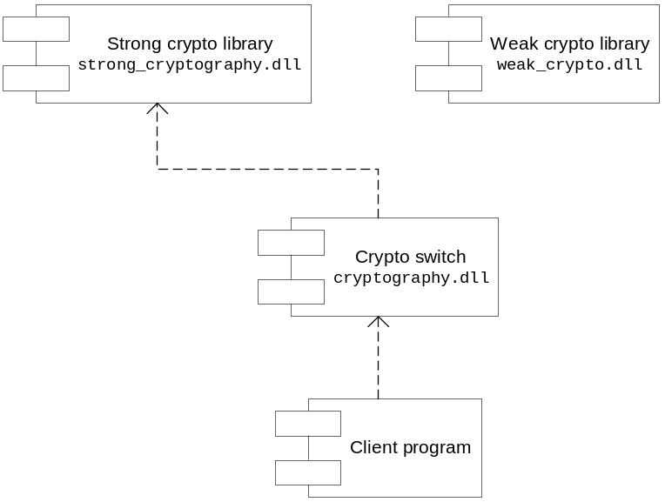

This setup allows a version of the emulator to be built that is not export restricted (including only the weak crypto library), which can be enhanced to use the strong crypto library merely by the addition of the appropriate dll.

Internal relationships
The following diagram shows the dependencies within the cryptography component (crypto switch is not shown).
Figure 5: Internal cryptography relationships
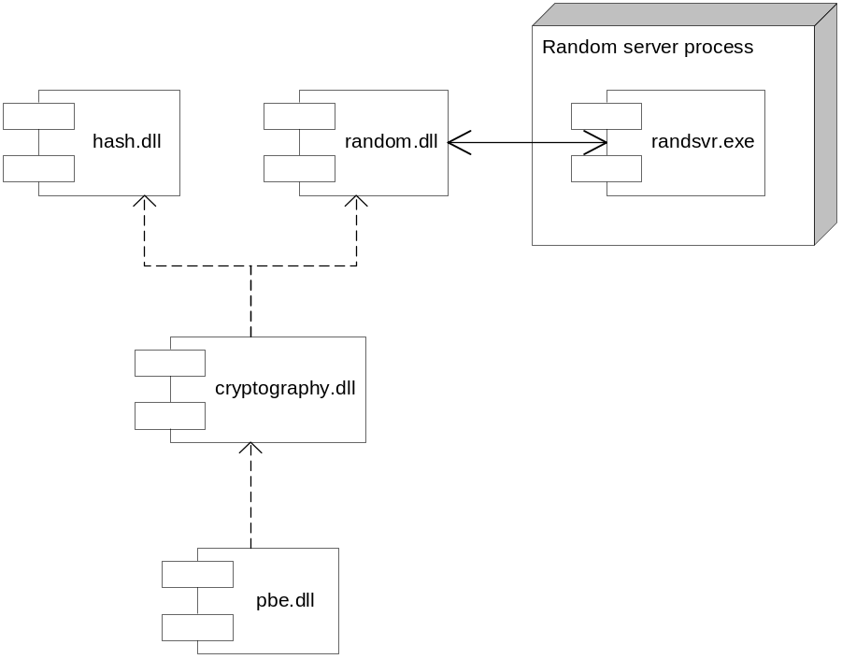

Crypto token framework

Component relationships
The following diagram shows component-level dependency relationships involving the crypto token framework.
Figure 6: Crypto token framework component dependencies
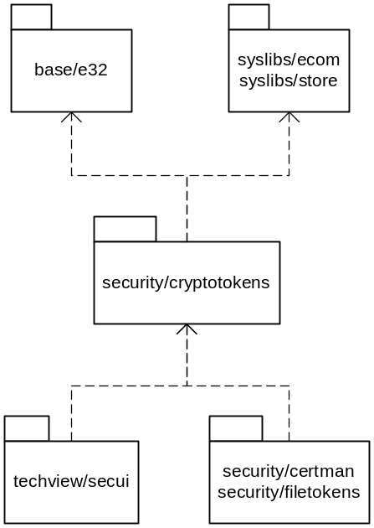

Subcomponents
Name and target | Purpose | Clients
Crypto token framework  ctframework.dll | An abstraction for cryptographic tokens such as WIMs.  Defines interfaces for tokens implementing:  - certificate storage  - key storage  - authentication (e.g. PIN) management  Provides an API for displaying security-related dialogs to the user (implementation supplied by UI) | security/certman  security/filetokens  techview/secui
Crypto token finder  ctfinder.dll | Provides an API to query which tokens are available on a device and construct instances of those tokens. This is mainly intended for internal use. | security/certman

File Tokens
The file tokens component provides software emulations of key store and certificate store tokens, using the APIs defined by the crypto token framework. To enforce platform security (and minimise the exposure of private keys to client applications in the case of the key store), this is implemented using a client/server architecture.
The key store maintains a database of key pairs in an encrypted file in the server’s private data area. This uses the password based encryption API provided by the cryptography component.
The following diagram shows component-level dependency relationships involving the file tokens component.
Figure 7: file tokens component relationships
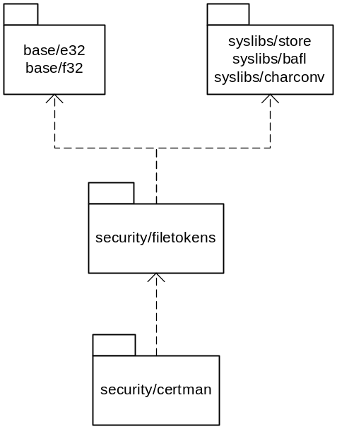

Subcomponents
Name and target | Purpose | Clients
PKCS#8 library  asnpkcs.dll | Provides an API to encode and decode PKCS#8 key pairs, including those encrypted with PKCS#5. | Internal use only  security/filetokens  security/certman
File tokens server  fstokenserver.exe | Server that provides the implementation of the file-based key store and cert store functionality. It also implements storage of certificate applications. | Internal use only  Called by fstokencli.dll
File tokens client  fstokencli.dll | Client for the file tokens server. Provides implementations of the crypto token framework interfaces for the software key store and cert store. | Internal use only.  Used by filekeystoreplugin.dll, filecertstoreplugin.dll, certstore.dll.
File key store plugin  filekeystoreplugin.dll | A crypto token framework plug-in for the file-based software key store. | Internal use only  Loaded by ctframework.dll, via ECom.
File cert store plugin  filecertstoreplugin.dll | A crypto token framework plug-in for the file-based software cert store. | Internal use only  Loaded by ctframework.dll, via ECom.
File tokens shared utilities  fstokenshared.dll | Utility dll including code that is needed by both client and server. | Internal use only

Internal relationships
The following diagrams show the relationships within the file tokens component:
Figure 8: Internal file tokens relationships
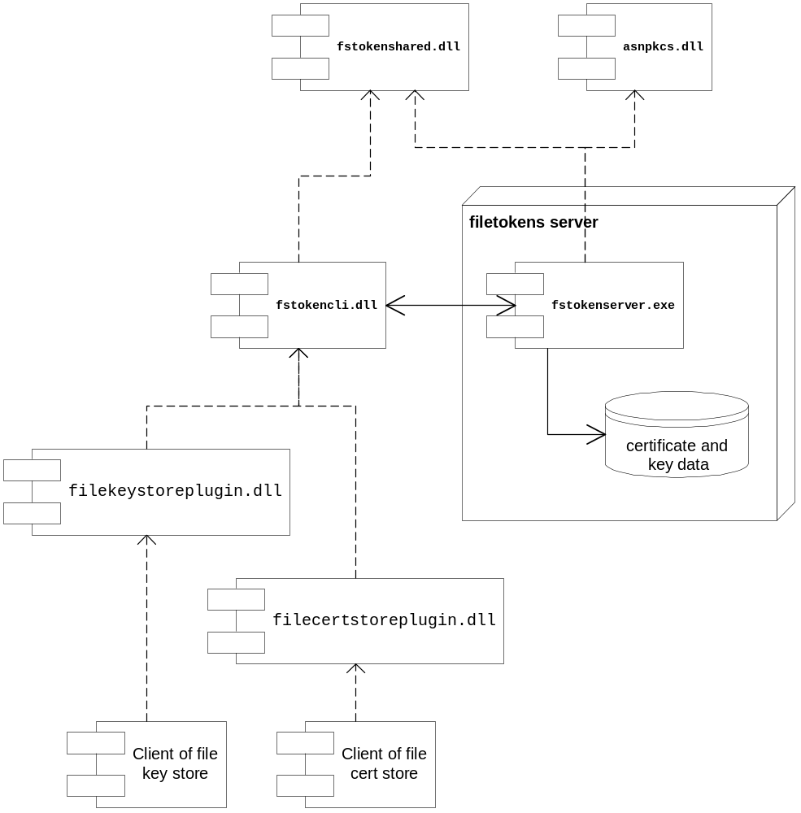

Certificate management
The component has been restructured to remove the dependencies from OCSP and pkixcert on certstore – this is necessary to allow them to be used by the TCB software install server.

Component relationships
The following diagram shows component-level dependency relationships involving the certificate management component.
Figure 9: Certificate management component dependencies
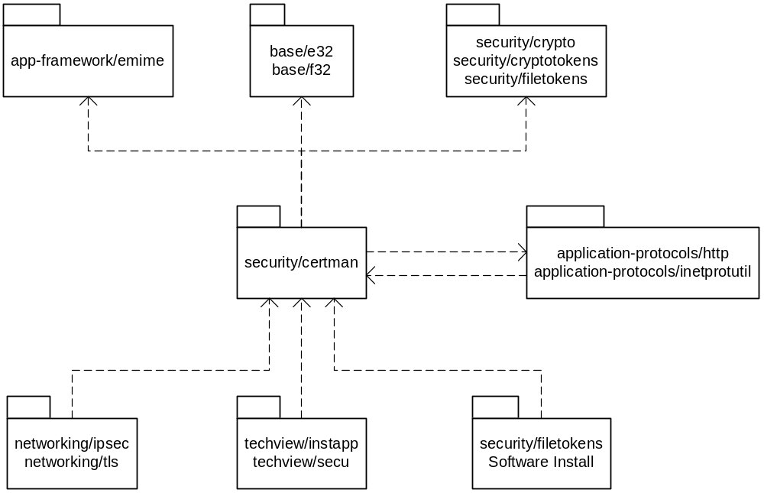

Subcomponents
Name and target | Purpose | Clients
ASN1 library  asn1.dll | Provides ASN.1 encoding/decoding functionality. Only the DER encoding is supported. | networking/ipsec  security/certman  security/filetokens  Software install  PKCS#12 and 7 libraries
Unified stores  certstore.dll | Provides the following APIs:  - unified certificate store  - unified key store  - certificate applicability settings | networking/ipsec  networking/tls  techview/secui  security/certman
Signed object library  crypto.dll  (Note the inappropriate name – this is not to be confused with cryptography.dll!) | Provides base classes for X509 and WTLS certificate implementations. | networking/ipsec  networking/tls  techview/secui  security/certman  security/filetokens  Software install  PKCS#12 library.
X500 library  x500.dll | Provides services for parsing and matching X.500 distinguished names and X.520 selected attribute types. | application-protocols/http  networking/ipsec  networking/tls  security/certman
X509 library  x509.dll | Implements parsing of X.509 digital certificates. | application-protocols/http  networking/ipsec  networking/tls  techview/secui  security/certman  security/filetokens  Software install
WTLS certificate library  wtlscert.dll | Implementation of WTLS certificates used by the WAP stack. | techview/secui  security/certman
OCSP library  ocsp.dll  ocsptransport.dll | Implements the OCSP using HTTP. | Software Install (certificate validity checks during installation of SISX packages and Java MIDlets.)  IAUN (certificate validity checks for  incoming application update notifications)
Certificate recogniser  reccert.dll | Recogniser for X.509 certificates. Supports DER-encoded certificates only. | No static dependencies.  Used by recogniser framework.
Key recogniser  pkcs8recog.dll | Recogniser for encrypted and cleartext PKCS#8 format keys (DER encoding only). | No static dependencies.  Used by recogniser framework.
PKIX library  pkixcert.dll  pkixcertbase.dll | Constructs and validates PKIX certificate chains against certificates in the certificate store. | networking/tls (server authentication)  techview/instapp  appstechview/secui  security/certman  Software Install (validation of package certificates)
PKCS#7 library  pkcs7.dll | Implements decoding of PKCS#7 signed objects. | No static dependencies  Used by PKCS#12 library.
PKCS#10 library  pkcs10.dll | Creates PKCS#10 certificate requests. | No static dependencies.
PKCS#12 library  pkcs12.dll | Implements decoding of PKCS#12 objects. | No static dependencies.
PKCS#’12 recogniser  pkcs12recog.dll | Implements a PKCS#12 recogniser. | No static dependencies
SWI cert store  swicertstore.dll | The ROM-based software install cert store. | Internal use only. Directly loaded by SWI.
SWI cert store plug-in swicertstoreplugin.dll | A crypto token framework plug-in to allow SWI cert store certs to be accessed through the unified certstore. | Internal use only.  Loaded by ctframework.dll, via ECom.

Internal relationships
The following diagram shows the internal relationships within the certificate management component.
Figure 10: certificate management internal relationships
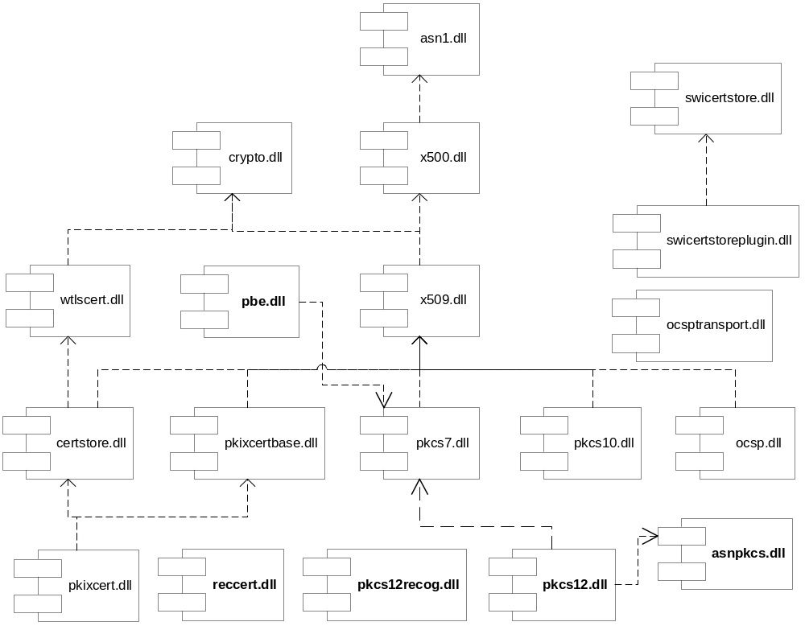

Certstore internal relationships
Certstore.dll supplies two important APIs – the unified cert store and the unified key store. The unified cert store provides a single point of access for clients to use certificates stored on the device. A certificate may reside in one of several stores – for example, the supplied file certificate store, or a licensee WIM implementation. For this reason, the unified cert store uses the crypto token framework to dynamically load cert store implementations available at runtime.
The following diagram illustrates the situation for the unified cert store, assuming that a licensee WIM implementation is present in addition to the supplied file cert store and SWI cert store. The crypto token framework itself is not shown:
Figure 11: unified certificate store relationships
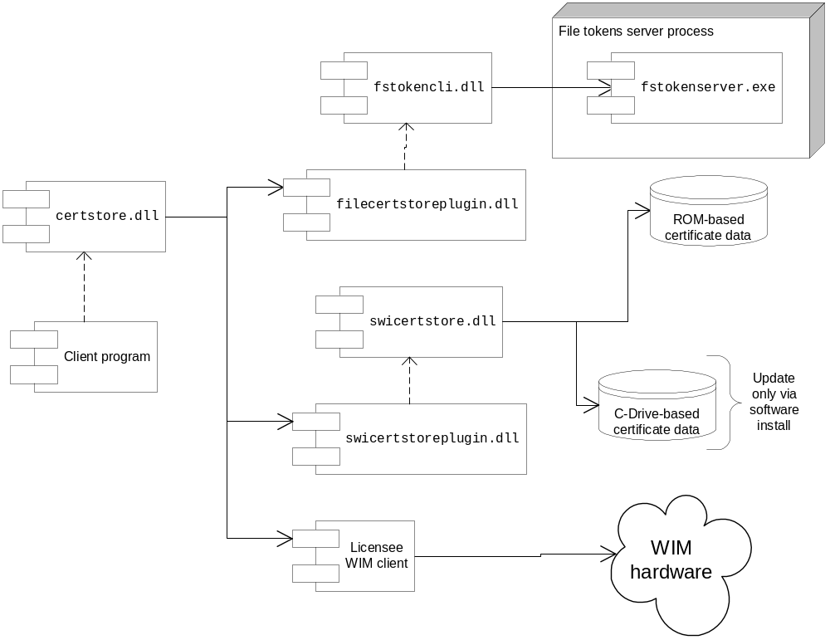

The situation is similar for the unified key store. As for the unified cert store, there may be licensee added WIM implementations. The following diagram illustrates this:
Figure 12: unified key store relationships
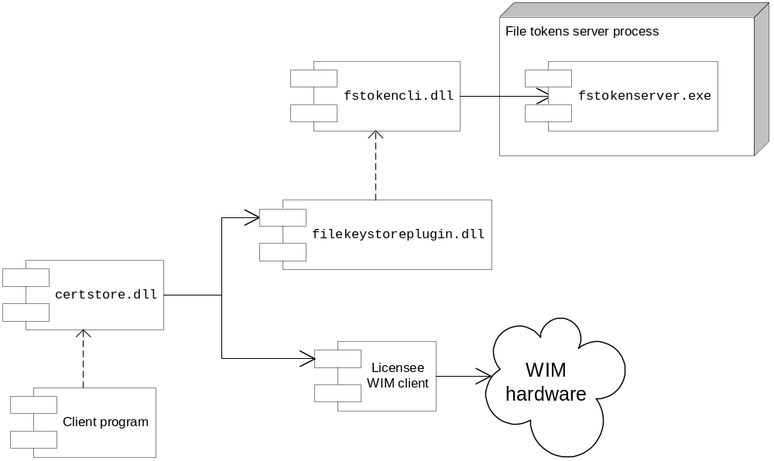

API Purpose — Further Elaboration

Certificate Store
The list of supported certificate application UIDs is now stored by the file tokens server.

SWICertstore
The SWI Certificate store is a special store designed to hold certificates relevant to the validation of software installations. It is, in fact, the only store used by SWIS – the software install server, and the OCSP component. It is, however, accessible – in a read-only fashion – via the standard unified certstore interface.
The store consists of a ROM component and a C-Drive component where the C-Drive component is searched (or processed) first. The C-Drive component – although technically writable – cannot be written-to by any certstore API, and can only be modified via software install (requiring TCB capability to achieve the modifications). It is anticipated that only device manufacturers will modify this part of the store.
Note that the C-based swicertstore CANNOT be written by SWI. See SecurityCheckUtil::CheckFileName() which explicitly blocks installing to the path. Another TCB process needs to do this.

Certificate Recogniser
The certificate recogniser does not currently support PEM-encoded certificates. Only binary DER certificates are supported.

OCSP Library & Transport
The library uses the URI of the certificate revocation server as specified in the corresponding certificate’s Authority Info Access attribute. If this attribute is not present in a certificate, the OCSP library uses a system-wide default OCSP server URI. Therefore UI implementers must provide a UI to set or change the default system-wide OCSP server URI.
An OCSP request can take a significant amount of time. UI implementers should provide the user with feedback on the request status and a possibility to cancel the OCSP request in progress. Please note, however, that no mechanism is currently provided to allow the implementer to provide significant feedback beyond "OCSP in progress”.
The library is split into two parts. ocsp.dll provides most of the data structures, and the ocsptransport.dll provides the ability to send OCSP requests over HTTP. The reason for the split is that this allows ocsp.dll to be used by the software install server, which is a TCB component. The transport library cannot be used by SWIS because it links against the http library, which is not trusted with the TCB capability.

PKIX Library
The chain validation process takes into account certificate trust settings for a particular “application”, or certificate usage. When a certificate chain needs to be built, the caller supplies a UID of certificate application (currently it can be software installation, MIDlet installation, OCSP and SSL/TLS server authentication). The chain builder looks in the certificate store for the corresponding root certificate to build a chain. Only applicable root certificates are considered, so if a certificate arrives that is signed with a root certificate present on the device, and that root certificate does not have the corresponding trust UID associated with it, the chain builder will not consider it for the chain construction, and the certificate validation will fail.
The library is split into two parts. pkixcertbase.dll provides the core implementation, and pkixcert.dll is a backwards compatible wrapper. The reason for the split is that pkixcert.dll links against certstore.dll, and cannot by used by the TCB software install server as it depends on ECom, which is not trusted with the TCB capability.

PKCS#7 Library
This library is currently used for decoding purposes only because there is no need to create PKCS#7-encoded objects on a device. In the future the library may be extended with encoding functionality, should such a need arise.

PKCS#10 Library
This library is provided for any application that needs to request a certificate from a certificate authority. Currently it is not used by any other system component.

PKCS#12 Library
This library is provided to allow any application to decode PKCS#12 data objects such as combinations of certificates and keys. No encoding provision is currently available.

PKCS#12 Limitations:
- Support for PKCS12BagSet BAG-TYPEs other than keyBag, pkcs8ShroudedKeyBag, certBag and safeContentsBag is not provided (i.e. no provision for crlBag, secretBag and any future BAG-TYPE)
- Support for CertBag CertTypes other than x509Certificate is not provided (i.e. support for sdsiCertificate and any future CertType is not provided)
- Support for EnvelopedData as content in an AuthenticatedSafe is not provided (i.e. only Data and EncryptedData is supported. Other PKCS#7 ContentInfo types are not used by PKCS#12)

Software Install APIs
The new Software Install architecture is modular and client-server based. Because software installation activities require unlimited access to a device, they are be performed by a trusted server component—Software Install Server, which is a part of TCB (REQ2681).

Components
API Name | Broad Purpose | Intended Users
Software Install Server (SWIS) | A TCB component that performs package validation and file installation or removal (REQ2681.3). | Used internally by helpers that request SWIS to process an installation or uninstallation request.
SIS Helper | Initiates native package installation, performs extraction on the package for SWIS, and performs initial package validation (REQ2681.2). | Used by other applications (web browser) to start native package installation, and by the Control Panel to start native application uninstallation.
Java Helper | Handles Java MIDlet installation, performs MIDlet validation including signature validation and OCSP, and communicates with Java AMS server in order to install MIDlets (REQ2681.1). | Used by other applications (web browser) to start MIDlet installation, and by the Control Panel to start uninstallation of a MIDlet. Does not have any links with SWIS.
OCSP Support Transport | Provides a transport for use with OCSP, which marshals the arguments using IPC to a server. This allows OCSP to be used by SWIS. | Used internally by SWIS.
UI Support Server | Provides communication with the UI for TCB components of Software Install. Receives callbacks which are relayed to the third-party client installer application. | Used internally by SWIS
Installed Apps Registry | Holds information about all the Java MIDlets installed on the device. Provides this information on demand to other components and applications | Used internally by JavaHelper, as well as by any external application that needs information on installed applications (for example, Add/Remove Control Panel applet, AppArc—to show the list of applications).
IntegritySupport | This component is responsible for backing up files to be replaced or deleted and restoring them in case installation or uninstallation fails. Also registers and un-registers applications with Installed Apps Registry (see Figure 15). | Used internally by Java Helper.
SisRegistryServer | A TCB/Allfiles application which holds information about all the native packages installed on the device. Provides this information on demand to other components and applications. Implements interface to enable clients to re-verify installed applications. Is partitioned into a restricted session API and an unrestricted API. | Used internally by SWIS, as well as by any external application that needs information on installed applications (for example, Add/Remove Control Panel applet, AppArc—to show the list of applications). Also used by the loader to re-verify installed applications.
IntegrityServices | This component is responsible for backing up files to be replaced or deleted and restoring them in case installation or uninstallation fails. | Used internally by SWIS
SisLauncher | This component is used to run files during install / uninstall. Now has power management capability to allow it to terminate applications during uninstall and install (both running and RUNWAITEND processes). | Used internally by SWIS
[Swi]Daemon | Component which watches for removable and pre-installed media, and will either launch the native installer application | Indicates the arrival and departure of media by informing the SisRegistryServer, and launching the native installer application.
DaemonPlugin | Allows customisation of the process which launches an installer application (e.g. a UI) and provides additional callback information to the implementer. If this optional licensee-provided plugin is not present, standard behaviour takes place. | The SWI Daemon Only
SwiDataProvider | This component provides data providers, which are capable of supplying data using a consistent interface, from memory or a file, or potentially a network connection. | Used by SISHelper and SWIS during installation of a SISX file, and the SisRegistryServer.
CafDataProvider | This component provides a data provider, which is used by SISHelper to access DRM encrypted SISX files. | Used by SISHelper and SWIS during installation of a SISX file.

Software Install Server APIs
API Name | Broad Purpose | Intended Users
RequisitesChecker | Verifies that the installation or uninstallation is possible before creating the plan and also verifies the plan once it exists. | Used internally by SWIS, by the Install Machine.
InstallMachine | This state machine component is responsible for organising the work of the other components during installation or uninstallation. | Used internally by SWIS.
RestoreMachine | The state machine responsible for the restoration of executables from a backup. This follows a similar security process to the original installation. | Used internally by SWIS.
SecurityManager | This component checks the integrity of SISX packages that come to SWIS. | Used internally by SWIS, by the Install Machine.
InstallationPlanner | Analyses the incoming package contents and creates a list of files to install or delete. The list is then processed by the PlanProcessor. | Used internally by SWIS, by the Install Machine
UninstallationPlanner | Analyses the request for an uninstallation and creates a list of files to delete. The list is then processed by the PlanProcessor. | Used internally by SWIS, by the Install Machine
PlanProcessor | Installs or removes files according to the installation or uninstallation plan. Assumes it is safe to replace or delete any file because other components must have made all the necessary checks earlier. | Used internally by SWIS, by the Install Machine.
FileExtractor | Requests SISHelper to extract the file on a chunk by chunk basis. Also uses UI Support Server to indicate progress to the UI. | Used internally by SWIS, by the Plan Processor.
ExpressionEvaluator | A small component used to evaluate expressions in SISX files, under a current environment. | Used internally by SWIS, by the Installation Planner.

Key External Relationships and Dependencies
The key relationships and dependencies of Software Install are shown in Figure 13.
Figure 13: Software Install key internal and external relationships
Java
Helper
SIS
Helper
OCSP Support
Transport
UI Support
Server
SWIS
EZLib
<<DLL>>
certstore
<<DLL>>
http
<<DLL>>
CAF
charconv
<<DLL>>
Java
AMS
<<DLL>>
SisRegistry
ocsp
<<DLL>>
Swi
Daemon
SIS
Launcher
Swi Data
Provider
Caf Data
Provider
Swi
daemon
plugin
Figure 14: Software Install Server internals
Installation
Planner
Security
Manager
UI Support
Server
Integrity
Support
OCSP Support
Transport
Installation
Machine
SisRegistry
Installation
Processor
Prerequisite
Checker
File
Extractor

API Purpose—Further Elaboration

Software Install Server
SWIS is a TCB component and does not load any dynamic code at run time (REQ2681.3.2).

Role
The Software Install Server receives an installation or uninstallation request from the UI Support Server via a client/server IPC call. It then starts the appropriate state machine, depending on whether an installation or uninstallation is being requested.
The sequence of events during installation is shown in Figure 17.

Dialog handling
Whenever the Software Install Server requires information from the user, it will use a client/server request to the UI Support Server. The previously uncompleted client message will be completed with a marshalled buffer indicating the data required by the server. The client gathers the necessary information from the user and replies to the server with a new message which is not completed until the next dialog request or until the installation or uninstallation is finished.

A note to UI implementers
When initiating an installation or uninstallation, developers must provide a pointer to an implementation of the Software Install UI call-back interface. As the dialogs must operate in a trusted context, the calling modules will require Trusted UI capability.

Completing installation or uninstallation
When installation or uninstallation is completed, the installation or uninstallation thread terminates, and this signals the main thread of the installation coordinator. This completes the last client’s message with an indication that the process is complete and any result data.

Cancelling installation or uninstallation
User may cancel installation or uninstallation at any time. In this case the server terminates the installation/uninstallation thread and performs the necessary housekeeping (REQ2681.5), which includes removal of any newly copied files and restoration of the files that were overwritten or deleted during installation, upgrade, or uninstallation. The device is essentially restored to the state it was in just before starting the cancelled operation.
Although SWIS accepts a cancellation request at any time, it finishes the current task before honouring the request.

CAF Enablement
Software Install is enabled to install DRM protected content. This is done by using the appropriate data provider in SISHelper and also ensuring that the DRM Intent are executed and evaluated during the installation. The execution and evaluation of rights are done by the Install Machine, using SISHelper.
Note that currently, the Java Installer UI - linking to the Java Helper - requires DRM capability since DRM-protected MIDLets need to be read (plaintext) in order to be installed. This may change in future, when the installation of MIDlets is handled by a dedicated server.

Concurrent Installations
Only one installation/uninstallation request can be handled at any given time; there is no support for concurrent installations and whenever another installation or uninstallation is attempted before the current one has completed the request will return with KErrBusy.

Backup/Restore
The software install synchronises with the backup/restore component so that actions of these components are mutually exclusive. There are two semaphores—one for software install and another for backup/restore. Each of these two components tries to lock the semaphore of another component before starting its operation.

Install Machine

Role
This component manages other components of installation or uninstallation. It creates an installation planner, integrity support object, security manager, file installer and installation log and maintains their interconnections.

Behaviour
SWIS performs the following actions for an installation.
- Creates a security manager.
- Creates an installation planner.
- Creates an instance of integrity support.
- Creates a requisites checker.
- Gets the controller by using a client/server call to SIS Helper.
- Evaluates the intent, if a DRM protected SISX file is being installed, to see if the installation should proceed.
- Uses the security manager to verify the signature, certificates and controller format. This may involve carrying out OCSP checks.
- Asks the requisites checker to check the prerequisites for the installation are met.
- Calls Plan() function of the installation planner. This will cause installation planner to gather the information needed to install or remove the application (this possibly involves asking the user for input). The plan is put into a CInstallationPlan object.
- Destroys the installation planner.
- Passes the CPlan object to the requisites checker, which validates the plan for consistency.
- Creates a plan processor and passes it the CPlan object returned from the installation planner. The object contains the list of files to install or remove. The integrity support object is also passed to the processor, so files can be backed up before being removed.
- Executes the appropriate intent on the content if installing a DRM protected SISX file. This may use up rights for the content.
- Asks the file installer object to install and remove files.
- Deletes the file installer object, the integrity support object, and the security manager.

Security Manager
The security manager verifies validity of incoming packages. This includes hash checking, certificate validation, OCSP, and capability checking. Multiple signatures and certificate chains for a single package are supported (REQ2679.1).
The security manager is capable of checking validity of SISX files only.
The security manager checks and assigns executable file capabilities as specified in the corresponding certificates (REQ2681.3.4.3).

OCSP Support Transport
The part of the subsystem responsible for making OCSP requests does not need the extensive capabilities required by SWIS and similarly, the networking capability required to make the request is not granted to SWIS. Therefore this functionality is partitioned-out into a separate server.
SWIS’s security is not compromised since the protocol returns a signed request and response pair (which can be compared with the original request).

Installation planner

Role
This component analyzes a package and creates a list of files to install or remove for the file installer. It gets the Sis::CController object it needs from SISHelper.
To get necessary information from the user, the installation planner uses the UI support server.
To get information about installed packages for dependency and upgrade checking, the installation planner uses the installed apps registry component.

Result
The result of the work of installation planner is a CPlan object, containing information on which files need to be installed and uninstalled, and information needed so that the registry can be updated.

Integrity support

Role
This component ensures that the device is always left in a consistent state. It backs up any files that are to be replaced or deleted during installation or uninstallation, and rolls back an interrupted installation or uninstallation by restoring backed up files.

Implementation
The integrity support library is implemented using a journal file that is created and updated at each point of the operation, and removed once the operation has completed. The journal file is a binary file containing a series of event records that describe the current operation status and allow finding out where the operation had stopped in case of a failure. Each operation has a start and end journal file entries associated with it.
To minimise the amount of space needed for file backup during upgrade or uninstallation, files that are to be replaced or deleted are moved to the backup location instead of copying them. This potentially helps avoiding a situation when uninstallation is not possible due to a lack of free disk space.
On file systems used in Flash memory cards rename operation requires some free disk space. The file backup/move to a backup location is performed in the most flash-friendly way to minimise possibility of running out of disk space.

Plan Processor
This component takes a CPlan object which lists files to install or remove and their hashes. The plan processor installs and removes files, using integrity support to ensure that an error will cause the files which have been copied up to that point to be removed. It also handles verifying the hashes of extracted files using Security Manager, and updating the registry.

SwiDataProvider
This component contains two data providers CDesDataProvider and CFileSisDataProvider. These are both implementations of the MSisDataProvider interface, one able to read data from memory, and one able to read data from a file.

CafDataProvider
This component contains a data provider CCafDataProvider, which is similar to CFileSisDataProvider in the SwiDataProviderComponent. It provides data from a file and is derived from the MSisDataProvider interface however it uses the CAF framework to allow access to DRM encrypted content.

Installed applications registry (legacy)
This legacy component maintains a list of installed applications on a device and provides this information on demand to other components. For each installed Java MIDlet application there is a corresponding registry file stored in /system/install/registry directory on the application drive.
If a client supplies UID of an application to IAR, it can retrieve application information without needing to have any special capabilities.
Figure 15: Installed Apps Registry relationships
Installed Apps
Registry
SWIS
Java
helper
Optional (not
present on
closed devices)
MInstalledAppsRegistry
MJavaRegistry
MAppVerifier
loader
Integrity
Support
Backup and Restore
IAR is used by Java Helper (Figure 15). Note that currently, Java Helper actually also makes a call to SisRegistry (not shown) to allow the Java Installer Infrastructure to determine the version of the Java Platform, since this version is published through the use of a stub SIS file, which is parsed by the SisRegistry.

Integrity services

Role
This component ensures that the device is always left in a consistent state. It backs up any files that are to be replaced or deleted during installation or uninstallation, and rolls back an interrupted installation/uninstallation by restoring backed up files.

Implementation
The integrity services library is implemented using a journal file on each drive named according to the Transaction ID. Another journal on drive C stores the drives involved in this transaction. The journal file is a binary file containing a series of event records that describe the current operation status and allow finding out where the operation had stopped in case of a failure.
To minimise the amount of space needed for file backup during upgrade or uninstallation, files that are to be replaced or deleted are moved to the backup location instead of copying them. This potentially helps avoiding a situation when uninstallation is not possible due to a lack of free disk space.
On file systems used in Flash memory cards rename operation requires some free disk space. The file backup/move to a backup location is performed in the most flash-friendly way to minimise possibility of running out of disk space.

SisRegistry
This component maintains a list of native applications installed on a device, and the relationships between them and their version. SisRegistry provides this information on demand to other components. For each installed application there is a corresponding registry file stored in /sys/install/registry directory of the C drive.
The SisRegistry server implements an interface to allow clients that have the appropriate capability (ReadUserData) to retrieve a list of installed applications (REQ2681.3.4.4). If a client supplies UID of an application to SisRegistry, it can retrieve application information without needing to have any special capabilities.
Figure 16: SisRegistry Relationships
IPC call into
IAR to register
an application
SWIS
Sis
Registry
External Client
Integrity
Support
Client IPC call into
SisRegistry to place
a query
logs internal
operations state
IPC notification of
inserted/removed
drives to update
internal state
SWIDaemon

Re-verification
On request of a sufficiently capable client, SisRegistry can provide information needed to re-verify package file integrity, which includes hash checks, certificate validation and OCSP (REQ2681.3.4.2). This is done by providing MAppVerifier interface implementation, which is used, for example, by the loader (Figure 15).

SisLauncher
This component is a server with ProtServ and PowerManagement capability, and used to run files on install or uninstall. Files can be run synchronously or asynchronously; when run synchronously the application is terminated after a timeout period if it has not done so already. The asynchronous option is not valid during uninstall or when the file is a temporary file that must be removed before installation ends.
SisRegistry is implemented as a server and IntegrityServices as a client-side DLL.
RUNWAITEND applications are not permitted to run longer than a configurable time. In addition, running applications may need to be stopped at uninstall time – forcefully if they do not (or cannot) handle graceful shutdown requests.

SIS Helper
The SIS Helper component initiates installation of native application packages and performs tasks that do not require TCB capabilities. It also owns the MSisDataProvider implementation and provides data extraction functions to SWIS.

The initial stage of a native package installation
The SIS Helper performs the following tasks.
- Initiates the request to the UI Support Server to start the installation.
- Extracts the controller from a SISX file, decompressing it if necessary, and sending the data to SWIS.
- Extracts files from the SISX file, when given a file handle by SWIS. This can be done in chunks so the progress bar can be updated while the extraction is in progress.
- Returns SWIS a list of drives and the amount of space free on each.
- Allows Software Install Server to execute and evaluate rights, if a DRM encrypted SISX file is being installed.

SwiDaemon
The SwiDaemon is a separate process which monitors drives for removable media insertion & removal. In doing so, it keeps the SisRegistry up-to-date and will also launch the native installer if a new (not currently installed) package is present.
To suppress multiple installation attempts, or intercept the launch functionality, licensees can implement a SwiDaemonPlugin. This ECom plugin, if present, will replace default behaviour and allow the licensee to perform functions such as:
- Suppress re-installation attempts for packages the user has already denied
- Launch a silent installer rather than the default installer
- Make intelligent choices about which MMC-based packages to install first etc.

Java Helper
The Java Helper component handles verification and installation of Java MIDlets. It is an independent component that does not require the rest of Software Install to be present on the device, thus enabling production of closed devices capable of installing Java MIDlets only.
The Java Helper component performs the following tasks.
- Prompts the user via a Trusted UI dialog that a MIDlet is about to be installed, displaying MIDlet suite name, vendor and signature(s).
- Performs the MIDlet validation according to the MIDP-NG standard. This includes signature and certificate validation, as well as JAD syntax and consistency checks.
- Creates any necessary AppArc files, including icons etc.
- Supplies all the files and any necessary information to the Java AMS for further installation actions.
- Updates the Installed Applications Registry.
Figure 17: Software installation sequence
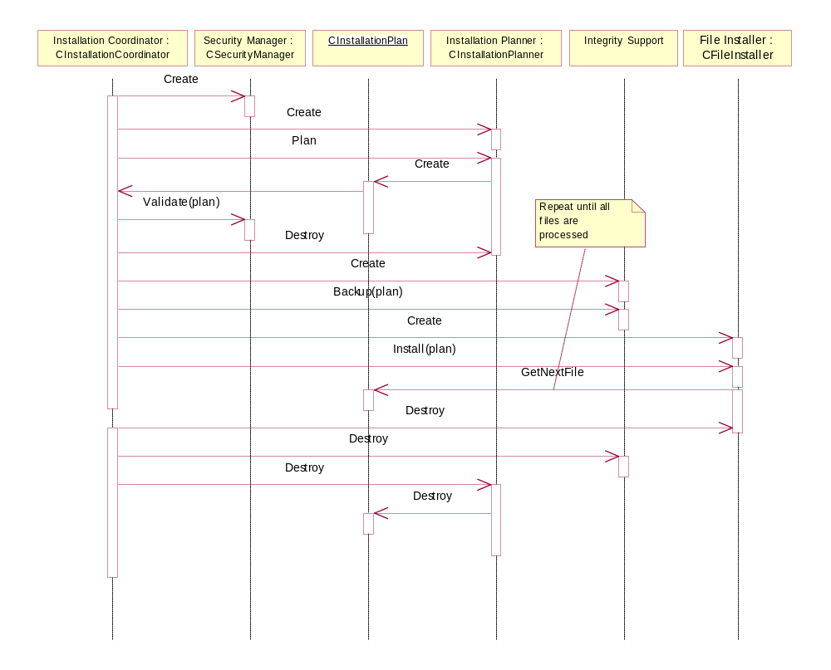

Content Access Framework
Note that CAF (v2) is now maintained by Base Services, so this section will remain here during the handover transition period.

APIs
The Content Access Framework provides third parties with a generic model to use as a base for DRM implementation. It enables software manufacturers to implement both DRM provider modules (agents) and DRM content consuming applications that can use the abstract interfaces without tying themselves to a particular implementation.
The following table summarises the provided APIs.
API Name | Broad Purpose | Intended Users
CAF | This is the CAF abstraction layer which provides clients with the ability to consume and manage DRM content. | Any Symbian OS or third party software that intends to handle incoming protected content (messaging infrastructure), or to access and use protected content (plugins, loaders, players, viewers etc).
CAFUtils | Provides utility classes, such as bit set operations. | CAF internal use only.
F32Agent | Provides CAF transparency by allowing the CAF APIs to be used consistently with protected as well as unprotected content. | CAF internal use only.
By default CAF builds as “CAF Lite” which is a stub wrapper around RFile. It allows applications to start using the DRM consumer API while the framework development continues. CAF Lite recognises agents, so F32Agent is not a part of the Lite build. It is possible to build the full CAF version by defining the NO_CAF_LITE build flag.
The APIs of the Lite build are the same as those of the full build, with the exception of F32Agent which is not available.
The CAF APIs can only be accessed by clients that have DRM capability (REQ2678).

Key Internal and External Relationships and Dependencies
The key relationships and dependencies of the Content Access Framework are shown in Figure 18.
Figure 18: CAF relationships and dependencies
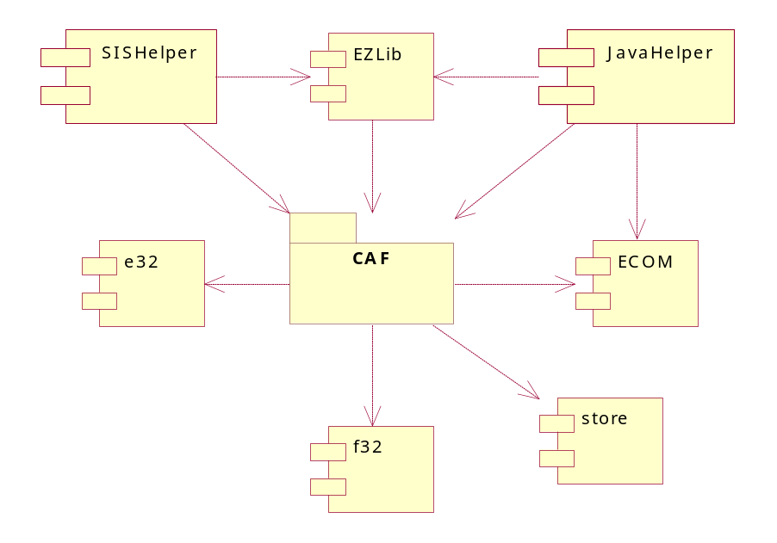

API Purpose—Further Elaboration
The DRM-enabled infrastructure is currently limited to the following areas:
- SIS Helper—using EZLib it is able to read DRM-protected SISX files. This type of protection addresses only the ability to read or install a SISX file and does not police any subsequent operations on the installed application (unless the archive contains protected material, which is handled separately after installation).
- Java Helper—it is capable of parsing and installing protected JAR files.
Future potential users of the CAF subsystem will be:
- The Java Loader (enabling the controlled load—but not run—of protected JAR files).
- The Messaging infrastructure—will identify DRM messages and forward them to the CAF infrastructure for processing.

TLS Provider

Component relationships
The following diagram shows component-level dependency relationships involving the TLS provider.
Figure 19: TLS provider component dependencies
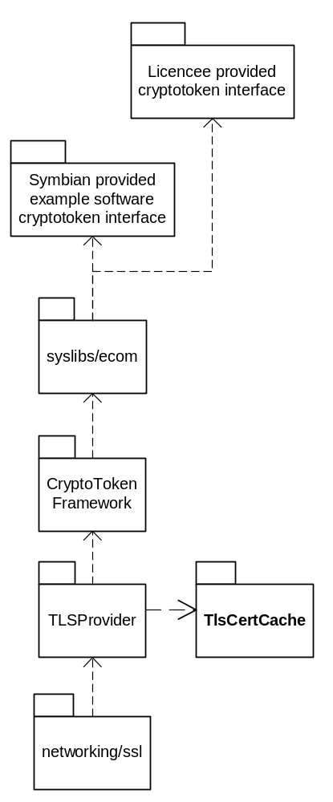

Subcomponents
Name and target | Purpose | Clients
TLS Provider  tlsprovider.dll | Provides cryptographic support for TLS 3.0 and 3.1 using a cryptographic token | Networking/ssl
Cryptographic token plugin  swtlstokentypepluginr.dll | Provides a software implementation of a cryptographic token | security/certman
TlsCertCache | Provides a means by which known ‘good’ certificates are cached so that TlsProvider doesn’t continuously require the user to validate certificates many times when multiple network connections are being employed to read one HTTP page. | Security/TlsProvider

Reference Certificate Store
The reference certificate store contains no executable code but consists of a single certificate store that contains the Symbian Signed production certificates (SymbianA and SymbianB) marked as suitable for Software Installation and revocation (OCSP) and trusted with all capabilities

Architectural Description and Elaboration

Client-server architecture
The following subsystem components employ client-server architecture to facilitate concurrent operation and data protection:
- File tokens server (for the file key store)
- Software Install
- SisRegistry

TCB vs. non-TCB code
Software Install is divided into the TCB (SWIS) and non-TCB parts. This is mandated by:
- The requirement to keep TCB code to the minimum and not introduce unsafe code into the TCB;
- The functionality (executable file installation) that requires TCB capability.
- The read/write protection demands of certain data critical to the integrity of the system

System Architectural Requirements
The architecture of the subsystem is determined by the requirements, the most important of them being:
- Platform Security—the planned gradual introduction of the secure platform features has a profound impact on the architectural solutions for the security subsystem. This includes data caging, improvements to the key store and certificate management, and a complete redesign or the software install component.
- Unencumbered cryptographic library—an in-house developed set of the essential cryptographic algorithm implementations, which is free from third-party IP. The set of implemented algorithms has been expanded to include AES, RC2-128 and PKCS#7 padding.
Licensees implement the UI layer that enables users to provide information necessary for the subsystem, such as passphrase entry, various confirmations, installation option and language selection, etc.

Security

Data caging
The subsystem components use data caging to protect their relevant information. For example, key store stores keys in its private directory. Additionally, some special protected directories are used by Software Install: /sys/hash holds executable hash and capability information, as well as certificate information for installed applications; /sys/registry holds Installed Apps Registry entries for native installed applications, and /sys/bin is a repository for all executable files that Software Install installs on a device.

Backup and restore
Software Install stores hashes and capabilities of installed executables and hashes of files marked as verifiable on restore, as well as their corresponding certificate information, in /sys/hash directory, so that upon restoration a check could be performed whether or not the files restored have been tampered with.

Capabilities
The security subsystem components need various capabilities to function properly. The most notable component is Software Install Server (SWIS) which is a part of TCB and has TCB+AllFiles capability. SisRegistry also has TCB+AllFiles capability.
Components that require network access (OCSP support transport server, Java Helper) have LocalServices and NetworkServices capabilities.
Components that require use of trusted UI (key store, certificate store, Java Helper, SIS Helper, SWIS) have TrustedUI+ProtServ capability.

Further Information

References
No. | Document Reference | Version | Description
<R1> | V:\Dev\GT\GT 0235 Juliette Security\Requirements\SGL.GT0235.201_Security_9.2_Functional_Specification_Superset.doc | 0.12 | Security Subsystem 9.2 Functional Description

Open Issues
The following issues need to be resolved before this document is completed.

Glossary
The following technical terms and abbreviations are used within this document.
Term | Definition
ASN.1 | Abstract Syntax Notation 1, an all-encompassing meta syntax description language used generally in computer security applications.
DER | Distinguished Encoding Rules, a method of ASN.1 encoding used in security. Means that for every security object there can be only one way to represent it in binary ASN.1 encoding.
DRM | Digital Rights Management, a set of technologies to prevent unauthorised use of copyrighted content.
HTTP | Hypertext Transfer Protocol, a protocol to transmit or receive chunks of specially formatted text.
IAR | Installed Apps Registry
OCSP | Online Certificate Status Protocol, a communication protocol to determine if a certain certificate is still valid.
PKIX | Public key infrastructure, the set of hardware, software, people, policies and procedures needed to create, manage, store, distribute, and revoke public-key certificates based on public-key cryptography.
TCB | Trusted Computing Base.
TLS | Transport Layer Security protocol.
WTLS | Wireless Transport Layer Security protocol.

Note that the SisInstaller component is no longer shown, since it simply provides legacy integrity installed-apps-registry support to the Java MIDlet Installer.
Digital Rights Management (see p.34)
Abstract Syntax Notation 1 (see p.34)
Wireless Transport Layer Security protocol
Online Certificate Status Protocol (see p.34)
Hypertext Transfer Protocol (see p.34)
Distinguished Encoding Rules (see p.34)
With the exception that currently, a stub SIS package is employed to indicate the version of Java present. This value is obtained by making a call to the SisRegistry.
It may also include a call to an optional external interface to allow custom JAD validation to take place.
This may become unnecessary.
Alternatively, moves them to the Java VM private directory.
Not available in the CAF Lite build.

